People are your real assets

Great leadership is cultivated, not just inherent. Our coaching programs blend essential soft skills with tailored development plans and leadership courses, designed to unlock the true potential of your organization’s talent.

Our integrated programs are perfect for organizations seeking customized, in-house development that aligns with your unique culture. Every soft skills instruction we offer features hands-on activities that reinforce learning and foster collaboration, leading to lasting growth. We can deliver these courses at your location or host them in a different setting.

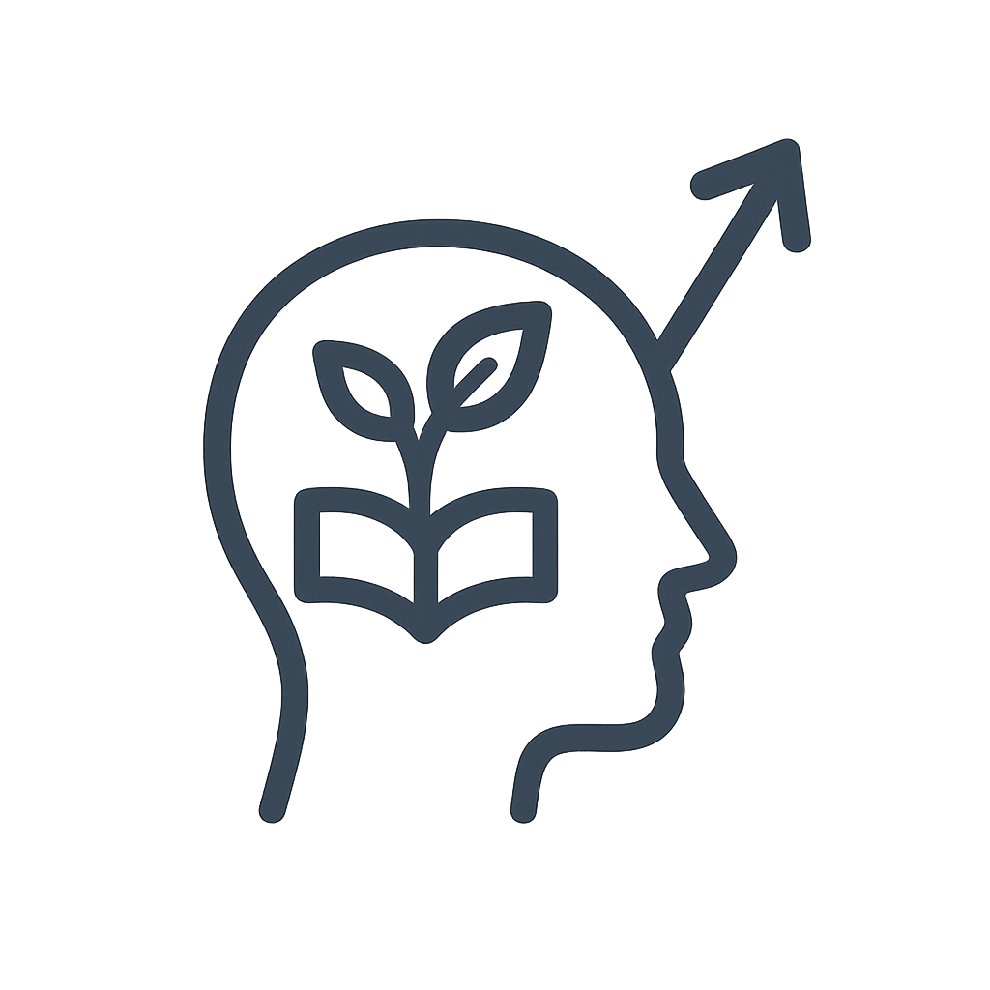

**Outlook**

We focus on delivering impactful experiences that genuinely shift perspectives. That’s what sets the stage for real skill development. Think of it as cultivating a strong foundation—when people’s attitudes evolve, new skills take root and grow far more effectively.



**Hands-on attention**

Effective leadership isn’t about buzzwords or fancy theories. It really boils down to specific habits that drive results. We empower leaders with straightforward, practical tools so the changes actually take hold. Results matter, and that’s what we’re focused on. No empty hype—just solid strategies that deliver, even when the pressure’s on.

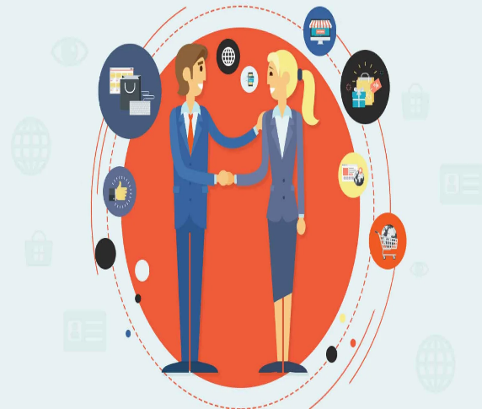

**Real-time Engagement**

Here’s the deal—Our offerings are all about hands-on work. We don’t waste your time with just theory or endless chatter; instead, we focus on practical excercises that line up with what you’ll actually face on the job. As you get into these activities, you’ll probably notice some familiar behaviors or habits creeping in, and honestly, that’s the whole point. That’s when real growth starts to happen.

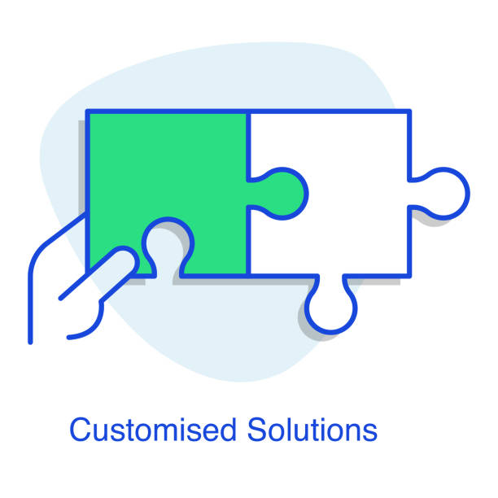

**Tailored Solutions**

Every program gets tailored to exactly what your team’s shooting for. Need sharper communication, presentations that don’t put everyone to sleep, or something else? We’ll build it. Plus, hands-on team building is baked in. People actually learn when they do, not when they’re just being lectured.

We lay out four main program types: single-session courses, blended formats that mix in-person and online stuff, journey-style deep dives for ongoing development, and online courses for those working remotely or split across locations. Topic range is wide—just ask and we’ll toss the full list your way.

Getting into leadership development, our programs are crafted specifically for your organization’s culture. We tie everything together—classroom to workplace—so what gets learned actually gets used. Your vision, mission, values? All woven in. We keep it practical, using your team’s language and real scenarios. Trainees walk out able to apply what they learned right away.

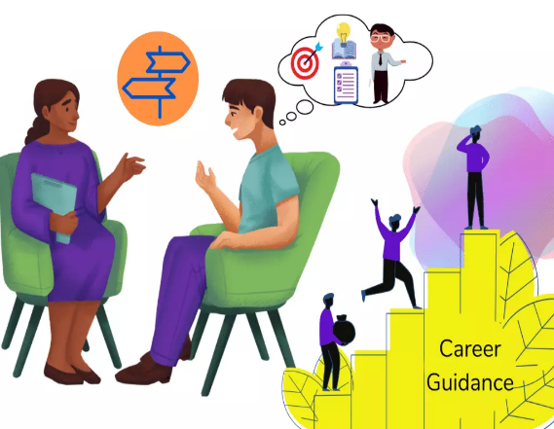

**For every level**

We provide guidance for every level—whether you’ve just joined the company or you’re part of senior leadership. Wherever you fit in your career, there’s something here for you. Most clients kick things off with our core offerings, but honestly, people almost always end up mixing and matching to get what works for their team. Adapting the material? No problem. We’re good at that.

Location-wise, it’s up to you. We can come to your office or set up sessions wherever suits you best. We’re here to make sure the program fits your organization, instead of the other way around.

**Our Services**



***Team Building***

Team building programs are essentially structured initiatives companies put in place to get employees working together more effectively. These aren’t just thrown together; they’re planned out and usually roll out over a dedicated day or even a whole retreat. The main idea? Strengthening team dynamics, improving communication, maybe uncover some unrealized leadership skills—basically set everyone up to function as a smoother unit.

Typically, you’ll find a mix of activities in these programs. Indoor stuff like problem-solving workshops, some outdoor challenges to shake things up, group games designed to break down barriers, and a few hands-on exercises thrown in for good measure. The hope is that by the end, your team’s not just better at their jobs, but they actually like working together, too.

In addition to focusing on enhancing communications and team spirit, we also design programs that encourage sharing lessons and reflections within the group.



***Executive Coaching***

In today’s supercharged, unpredictable business landscape, executives face an endless stream of challenges—and the speed of decision-making? Off the charts. Leaders have to move fast, trust their instincts, and stick by their choices, even when the stakes are sky-high.

It’s hard to overstate the value of a savvy, trusted advisor—a real partner who’ll spot the blind spots, dig into confidential issues, and lay out all the options without sugarcoating anything. Honestly, serving that candid sound board for senior leaders is more than just a job. It’s a powerful, high-stakes role that can make or break outcomes across an organization.

Our advanced Executive Coaching Program is where you take your coaching expertise to a higher level. With this program, you’ll help leaders dodge common pitfalls and put their focus on performance that lasts—not just hitting this quarter’s numbers but building success that sticks.

***Coaching Types***

* Performance coaching: Think of performance coaching as a results-focused partnership. These coaches aren’t interested in endless pep talks—they’re here to give employees solid strategies, actionable tools, and the kind of feedback that actually moves the needle. It’s all about tangible improvement in how work gets done, day in and day out.
* Developmental coaching: For professionals looking to expand their leadership scope, developmental coaching delivers. It’s designed for those who know that climbing the ladder means building skills beyond today’s job; it’s about learning how to navigate complexity, balance multiple demands, and adapt with resilience when challenges hit.
* Skills coaching: Got a professional weakness that’s slowing you down? Skills coaching is direct and practical. Whether you want to sharpen your public speaking, manage your time better, or handle conflicts more effectively, this coaching zeros in and helps you develop targeted competencies that make a difference fast.
* Career coaching: Thinking about making a leap or climbing to the next tier? Career coaching is essentially a career strategy session. Coaches in this category act as thought partners, helping map your best path forward and steer around career pitfalls before you hit them.
* 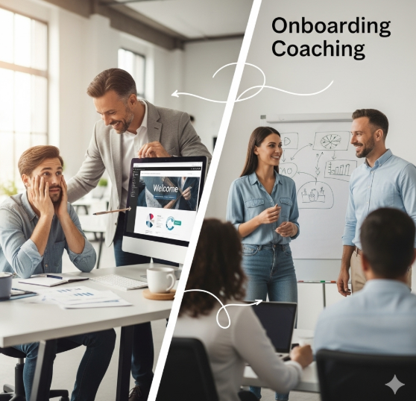Onboarding coaching: Starting fresh at a company or in a new position? Onboarding coaching smooths the transition, accelerates your learning curve, and gets you up to speed with both the business objectives and the often-unspoken workplace dynamics.



* Transformational coaching: This is the go-to for professionals seeking meaningful shifts—not just in what they do, but how they think. Transformational coaching digs deeper, addressing underlying beliefs and mindsets. The aim? To spark real change in perspective and drive new behaviors that support long-term success.
* Team coaching: When a team’s output matters as much as individual excellence, team coaching delivers. A skilled team coach aligns group goals, cuts down on

miscommunication, and sharpens collective performance. The result? Cohesion gets stronger, and so does the bottom line.

* Strategic coaching: Ready to think big? Strategic coaching is for leaders and teams eyeing ambitious, long-term results. It’s about building and executing plans that align with business strategy—ensuring that every move supports the organization’s broader goals.
* Organizational or business coaching: If your business feels stuck or scattered, organizational coaching provides clarity and direction. These coaches work holistically with companies—identifying overarching goals, addressing systems-wide issues, and improving productivity across departments. It’s the business equivalent of an organizational tune-up.
* 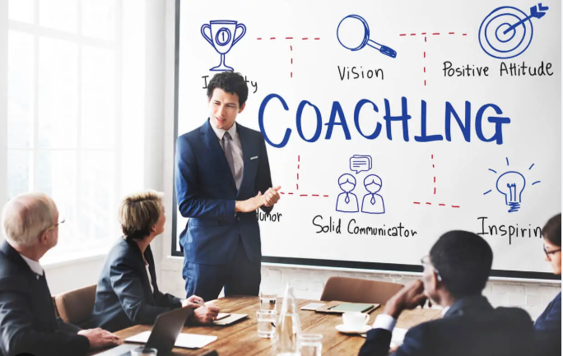Management coaching: That jump into management can be daunting. Management coaches offer hands-on learning—teaching new leaders how to plan, organize, and motivate teams effectively, all while sharpening core skills for resource management and delegation. The focus is on transitioning managers from overwhelmed to capable, fast.
* Executive team coaching: Executive team coaching is a strategic investment. It supports senior leaders and their teams in communicating more effectively, collaborating at a higher level, and delivering top-tier performance. From conflict resolution to shared goal setting, everything’s designed to maximize leadership impact.
* Executive leadership coaching: For executives on the rise, leadership coaching is key. These coaches are trusted advisors, challenging leaders to refine decision-making, develop vision, and inspire teams—preparing high-potential talent for the next level and ensuring succession pipelines stay strong.

***Benefits***

Executive coaching drives real results—no fluff. Individuals can see performance climb as much as 70%, which translates directly to meeting goals and communicating more clearly with colleagues.

Teams? They don’t miss out either. Coaching often boosts team output by around 50%, moving everyone toward tighter collaboration and more consistent wins.

Leadership growth is a huge upside here. We’re talking about real improvements in decision-making, communication, and that crucial emotional intelligence every effective leader needs.

Let’s not forget personal growth: coaching participants report better self-awareness, can handle stress more effectively, sharpen up mentally, and generally feel more motivated on the job.

And when it comes to ambitions—they’re not left to chance. Executive coaches give structure, working side-by-side to break down big dreams into SMART goals with firm deadlines. So, you can expect less wishful thinking, more real results.

***Group Training***

In collaboration with certified trainers and approved training centers we offer training courses for middle management and new joiners in areas covering HR, Finance and Health and safety.

For full details of available training programs Click here

